**ASSIGNMENT-24.2:**

A database named custom is created and used. The temperature data is loaded into the database. The contents of the table is displayed.

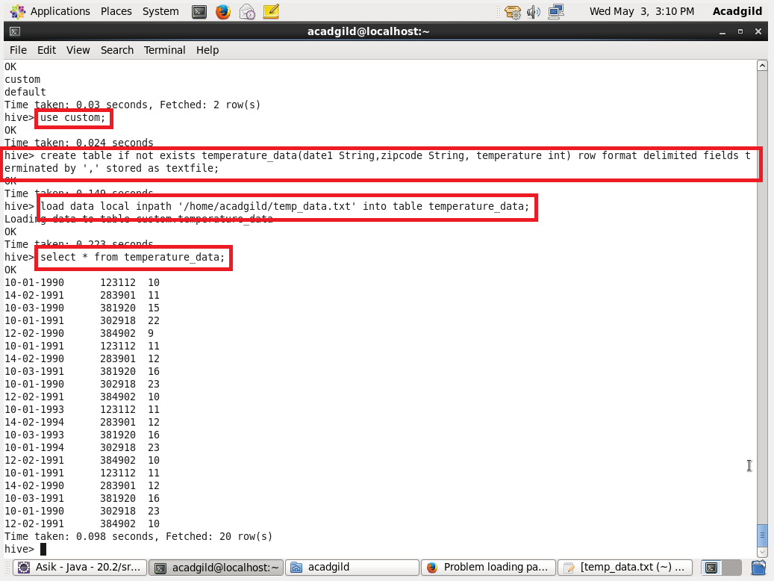

**QUESTION 1** : Fetch date and temperature from temperature_data where zip code is greater than 300000 and less than 399999

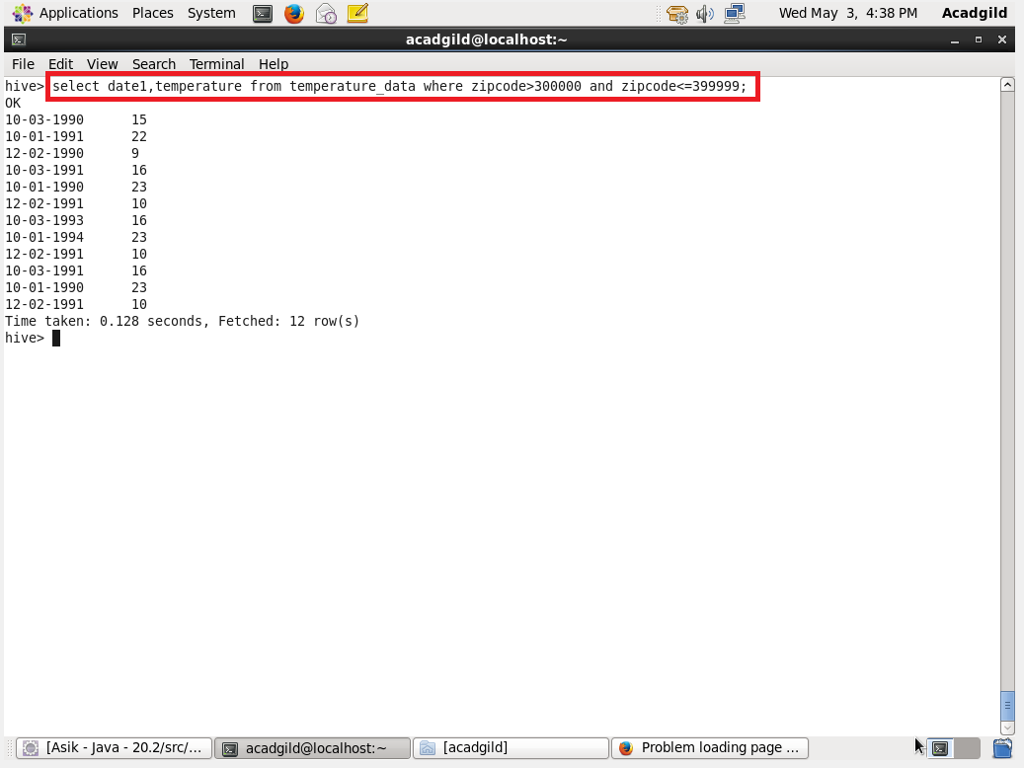

**QUESTION 2** : Calculate maximum temperature corresponding to every year from temperature_data table.

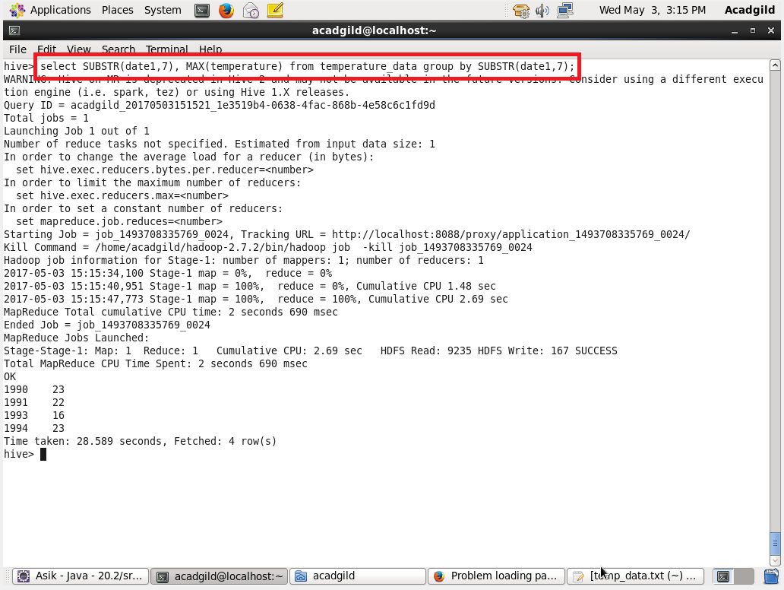

**QUESTION 3**: Calculate maximum temperature from temperature_data table corresponding to those years which have at least 2 entries in the table.

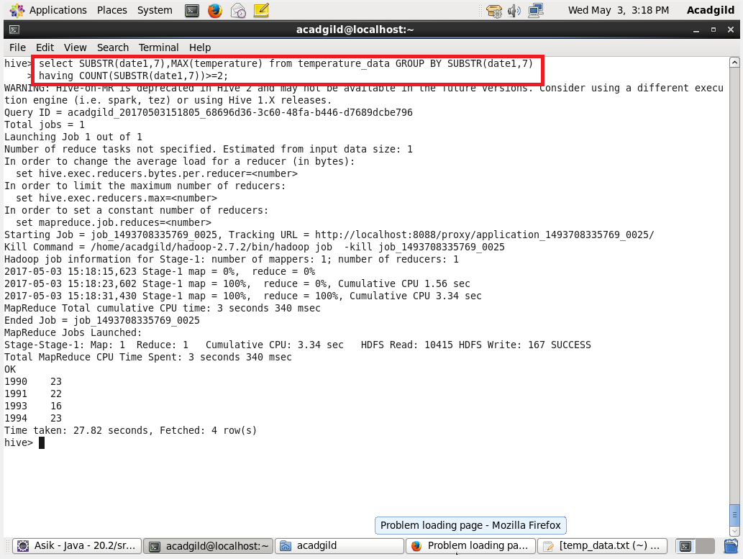

**QUESTION 4** : Create a view on the top of last query, name it temperature_data_vw.

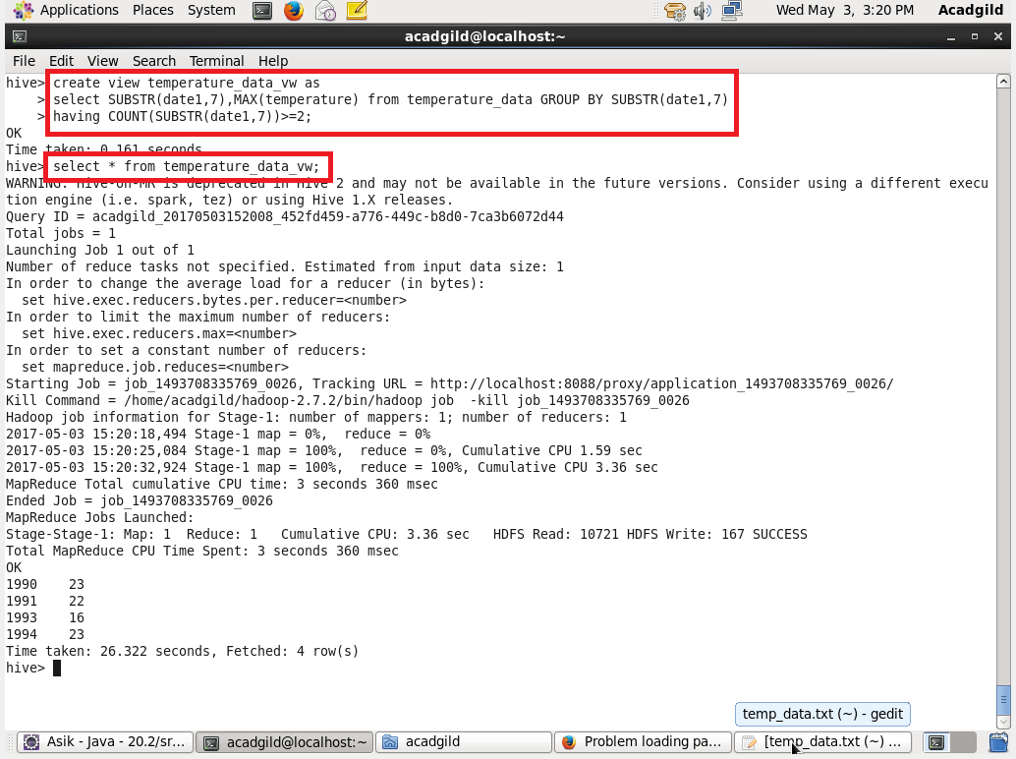

**QUESTION 5** : Export contents from temperature_data_vw to a file in local file system, such that each file is '|' delimited.

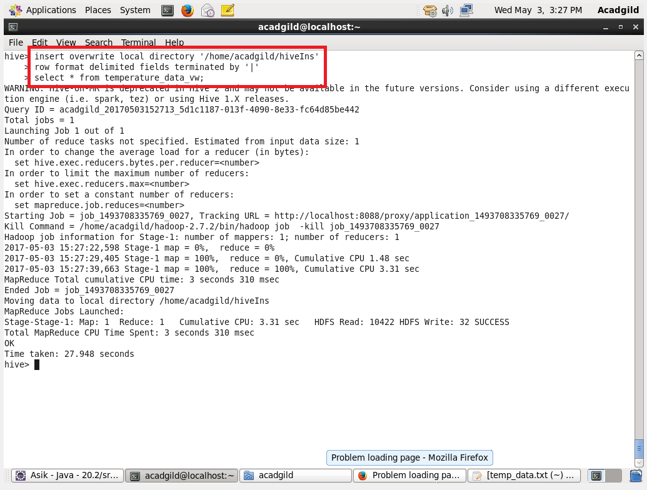

The contents is exported into the local file system :

